The Islamia University Bahawalpur
Department of Information Technology
Faculty of Computing



Software Requirement Specification
<Smart pet clinic>
Version 1.0
Supervisor
Mam Sara Fareed
Submitted by
Ali Waris
F22BINFT1M01161

Session 2022-2026


Smart Pet Clinic
Software Requirements Specification
Version:1.0
05/12/2025

Prepared By:
Ali Waris

Prepared For:
Information technology
Instructor: Mam Sara Fareed
Acknowledgement

We truly acknowledge the cooperation and help make by Mam Sara Fareed, Lecturer, Department of Information technology , The Islamia University of Bahawalpur. She has been a constant source of guidance throughout the course of this project. We would also like to thank Mam Sara fareed for her help and guidance throughout this project.

Revision History

Date | Description | Author | Comments
<date> | <Version 1> | <Your Name> | <First Revision>

Document Approval

The following Software Requirements Specification has been accepted and approved by the following:

Signature | Printed Name | Title | Date
 | <Your Name> | Lead Software Eng.

Table of Contents

REVISION HISTORY II
DOCUMENT APPROVAL II
- INTRODUCTION 1
  - PURPOSE 1
  - SCOPE 1
  - DEFINITIONS, ACRONYMS, AND ABBREVIATIONS 1
  - REFERENCES 2
  - OVERVIEW 2
- GENERAL DESCRIPTION 3
  - PRODUCT PERSPECTIVE 3
  - PRODUCT FUNCTIONS 3
  - USER CHARACTERISTICS 3
  - GENERAL CONSTRAINTS 4
  - ASSUMPTIONS AND DEPENDENCIES 4
- SPECIFIC REQUIREMENTS 4
  - EXTERNAL INTERFACE REQUIREMENTS 5
    - User Interfaces 5
    - Hardware Interfaces 5
    - Communication Interfaces 5
    - Software Interfaces 5
  - FUNCTIONAL REQUIREMENTS 5
    - Appointment 5
    - Login 5
    - Doctor 6
    - Payment 7
  - USE CASES 7
    - Use Case #1 8
    - Use Case #2 9
  - Use Case Diagram 15
  - NON-FUNCTIONAL REQUIREMENTS 15
    - Performance 4
    - Reliability 4
    - Availability 4
    - Security 4
    - Maintainability 4
    - Portability 4
  - INVERSE REQUIREMENTS 4
  - DESIGN CONSTRAINTS 4
  - LOGICAL DATABASE REQUIREMENTS 4
  - OTHER REQUIREMENTS 4
- ANALYSIS MODELS 4
  - SEQUENCE DIAGRAMS 5
4.3 DATA FLOW DIAGRAMS (DFD) 5
4.2 STATE-TRANSITION DIAGRAMS (STD) 5
- CHANGE MANAGEMENT PROCESS 5
- APPENDICES 5
  - APPENDIX 1 5
  - APPENDIX 2 5

Introduction

This project is designed to provide automatic and easy way for making appointments to veterinary doctors, t treatments and dealing with emergency situations. Normally people first must find hospitals, then they visit them and then apply for appointment that has a long procedure. On the day of check-up, they again visit hospital. Also, sometimes the doctor may be absent. But they come to visit the doctor as per their appointment day. This may waste someone’s precious time. For emergency; people must find contacts for hospitals and ambulance at that critical situation. There may be no doctor available in a hospital near to them for their pets, if ambulance take them to that hospital, it endangers the lives, also the patient can buy accessories and food for the pets To overcome these problems, this project is designed and developed that ensures the security of lives by automating system in emergency case and to reduce the unnecessary visits to hospitals and doctors.

Most of the manual system load of reception can be reduced and replaced by adopting this web app. In manual system there may be some patient waiting too long for a minor check-up and they may have no need to come physically to the doctor. Through this app the online check-up can be conducted through sending videos and respond by doctor and his assigned prescription. The Location Tracker is used in this app by using Google map API to find the curpayment location of patient in emergency case.

Purpose
- Smart Pet Clinic is for all the problems and for all the people as well. You don't need to go to hospital for small issues. You just have to inform your doctor by sending videos and doctor will respond you either in case of assigned prescription or home remedy. Every person doesn't have the know-how about the usage. So by this project, you can interact with your doctor by chatting in any language easily Stay Safe, Live Long.
- Auto Response
- Emergency handler
- Emergency request

Project Scope
Smart Pet Clinic Web app is to bring the manual reception system of appointments up to technological modernity. The user will no longer need to visit and search hospitals and their specialist doctors. He can find in one platform. They will get a secure platform that they can trust and get help in case of emergency and the accessories and food of the pets will be available to buy online.

The smart system, following operations will be performed:

- 1 | Online appointments will be made on request by user and acceptation by doctor.
- 2 | User will be able to view and request differ payment doctors of multiple hospitals (registered).  The record of the pets and doctor consultation will be saved to remind the history of pet health.
- 3 | It will be ensured that the user cannot request for more than one appointment at the same time. If he does by himself many times, he will be declared as “Fake user”.
- 4 | If the Doctor is absent, all of his appointments will be canceled, and notification will be sent to all of his patients.
- 5 | The user of the system will be able to buy food and accessories online (FAO).
- 6 | Patient and Doctor will be able to communicate with each other online by chat, if the check-up doesn’t take so long.

Definitions, Acronyms, and Abbreviations
FAO ---- Food and accessories
GUI ---- Graphical User Interface
SRS ---- Software requirements specification
SQL ---- Structured Query Language
SPC ---- Smart Pet Clinic
LDR ---- Logical Database requirements
ER ---- Emergency Request

References

https://junnivet.com/

For appointment system, Google Forms is used.

Interface is difficult.

Only introduction of pets is given.

https://ziavets.business.site/

For appointment Facebook page is used.

Only information about pets is given.

Simple form for contact is given

http://www.saleemvets.com/

Only information will be given about pets.

http://www.gvhospitals.com/

Buy and sell of pets.

Information about pets

http://www.ranaspetcarecenter.com/

Information about pets

https://petsworld.pk/

Buy and sell of pet accessories and products.

http://www.asimpetsclinic.com/

Only clinic location through map is given.

https://jamshedpetshospital.business.site/

Only information about pets

Overview
Smart Pet Clinic (SPC) organization gives Pet Clinic service for both foreign and local customers. This organization does its daily work by providing their service to the patients manually. The organization uses a manual system for reserving, payment, register and to keep record of all the appointed activities and patient information. The detailed existing system functions are listed as follows: -
- During Doctor Appointment the customers appoint Doctor by making a phone call to the Hospital; Otherwise, he/she is expected to go to the Hospital to make appointment.
- During appointing doctor’s the customer personal information, payments status and fee agreements are filled in the doctor appointment agreement form in order to hold legal contract between the patient and hospital for appointing the doctor.
- The hospital normal work time schedule is from 8:00am – 10:30pm; therefore, the hospital gives services for fourteen and half hours a day.
- The hospital makes a general report about the appointed doctors once at the end of the month and generates a report to the admin.

Users of the existing system
- Admin
- Doctor
- Patient

General Description

Online pet care fill in the gaps of pet healthcare by providing quick access to advice and treatment options via video consultations, phone calls, and live chats. Many also provide other types of care including nutrition counseling, behavioral training, and medication.

Product Perspective

The Main perspective of Smart pet Clinic application to support Smart pet Clinics in many ways such as Online Consultation, medical calculations, information on websites, interactive webinars, etc. Pharmaceutical companies offer online services to support veterinarians but it is the perceived usefulness that determines the usage of such support.

Product Functions
- Admin: Admin is the main person by which every user will be employees and clients activities will be controlled.
- Login: Login differs’ the types of login we have in our system namely admin, employees and patient. It’s very important that every registered user has to select their designated login method to login into the website.
- Register: Registering the employees will be in the hands of admin. He will give the employees a user name / id and password to proceed further to create the details and further validations. On the other hand, the clients can register themselves using the registration form.
- Employee: Employees are the person who will serve the clients. They will be able to see the rosters and the bookings and serve the client.
- Client: The clients are the persons who will take the service of the system to book a fleet online through the application. They can see the available cars and book it according to it.
- Vehicle Booking: The bookings can be created by filling up the booking form by the clients.

User Characteristics

Admin:
  - Admin can login to the system.
  - Verify the car information database.
  - Generate price strategy.
  - Handle the payment system.
  - Finalize the appointment.
  - Cancel the appointment.

Employee:
- It updates the database.
- Give information to the patient about the doctor.
- Provides the alternatives.
- Maintain contacts.

Maintenance Manager:
- It checks for the maintenance.
- Give to the maintenance.
- Give information to the admin.
- Update the database.

Customer:
- patient can login to the system.
- Visit the website.
- Place the appointment.
- Cancel the appointment.

General Constraints
Our project is limited to the following
The project scope is limited to automate the existing system.
- GUI is in English which means users must have some knowledge of English.
- It cannot work without internet.
- It cannot work online payment Without Credit/Debit Card.
- Without power there is no service.

Assumptions and Dependencies

2.5.1 Regularity Policies:
Each center user has account created and authenticated by admin. This Website can be
accessible within company’s intranet and other users can see the all details about the franchisee. Each user has to first login itself to present him/her after entry in franchisee. This will be done automatically; no user can share their username and password to each other.

2.5.2 Hardware Limitations:
There is no limitation in the operating system in which Car Rental System will work. However, the Car Rental System and the database will work on a server that needs to be always online. Users can access the system with any internet browser

Specific Requirements
System requirements are statements, in a natural language plus diagrams, of what services the system is expected to provide to system users and the constraints under which it must operate.That describes user goals or tasks that the users must be able to perform with the system. User requirements therefore describe what the user will be able to do with the system.

External Interface Requirements

3.1.1 User Interfaces
- All the users will see the same page when they enter in this smart pet clinic website. This page asks the users a username and a password, or if user is not already registered with website then he has to create account.

- After being authenticated by correct username and password, user will be redirect to their corresponding profile where they can do various activities.
- The user interface will be simple and consistence, using terminology commonly understood by intended users of the system. The system will have simple interface, consistence with standard interface, to eliminate need for user training of infrequent users.

3.1.2 Hardware Interfaces

No extra hardware interfaces are needed.
- The system will use the standard hardware and data communication resources.
- This includes, but not limited to, general network connection at the server/hosting site, network server and network management tools.

Communications Interfaces
- This system use communication resources which includes but not limited to, HTTP protocol for communication with the web browser and web server and TCP/IP network protocol with HTTP protocol. This application will communicate with the database that holds all the appointment information.
- Patient can contact with server side through HTTP protocol by means of a function that is called HTTP Service. This function allows the application to use the data retrieved by server to fulfill the request fired by the Patient.

Software Interfaces

OS: Windows 7, Linux Web Browser: The system is a web based application; patients need a modern web browser such as Mozilla Firebox, Internet Explorer, Opera, and Chrome.

The computer must have an Internet connection in order to be able to access the system.
.

Functional Requirements
Functional requirements: these are statements of services the system should provide, how the system should react to particular inputs, and how the system should behave in particular situations. It specifies the software functionality that the developers must build into the product to enable users to accomplish their tasks.

Appointment

The system must allow the patient to register for appointment.
- The system shall allow the patient to view detail description about particular Doctor.
- The system must notify on selection of unavailable Doctor while appointment.
- The system must allow the patient to select specific Doctor using diffepayment search category while appointment.
- The system must view list of available Doctors appointment.
- The system shall allow the patient to cancel appointment using appointment confirmation number.
- The system shall allow the Doctors to update appointment information.
- The system shall allow the Doctors to view appointment made by patients.
- The system must be able to provide a unique appointment conformation number for all successfully committed appointment.
- The system must be able to display appointment’s summary for successfully committed appointment.

Log in
- The system should allow Admin to login to the system using their username and password.
- The system should allow Doctor to login to the system using their username and password.
- The system shall allow the System Admin to create new user account.
- The system shall allow Admin to change account password.
- The system shall allow Doctors to change account password.
- The system shall allow Doctors to logout.
- The system shall allow System Admin to login to the system using their username and password.
- The system shall allow System Admin to logout.
- The system shall allow System Admin to change account password.
- The system shall allow patient to Sign up.
- The system shall allow patient to login to the system using their username and password.
- The system shall allow patient to logout.
- The system shall allow patient to change account password.
- The system must allow the patient to select specific Doctor using diffepayment search category while Appointment.
- The system must view list of available Doctors during Appointment.
- The system shall allow the patient to cancel appointment using Appointment confirmation number.
- The system shall allow the Doctors to update Appointment information.
- The system shall allow Doctors to view Appointment made by patients.
- The system must be able to provide Appointment conformation number for all successfully committed Appointments.

Doctor
      - The system should allow Admin to register new Doctor.
      - The system shall allow Admin to select Doctor in the list.
      - The system shall allow patient to select Doctor in the list.
      - The system shall allow Admin to Search Doctor by specific record.
      - The system shall allow Admin to update information of the Doctor in need of modification.
      - The system shall allow Admin to display all lists of Doctor.
      - The system shall allow Admin to display all available Doctor.
      - The system shall allow Admin to display all off duty Doctor.

Payment
- The system shall allow Admin to register patient into payment list.
- The system shall allow Admin to update about patient payment record details in the payment list.
- The system shall be able to save all changes made on the patient payment list.
- The system shall allow Admin to select patient payment record by specific search category.
- The system shall allow Admin to search payment record of patient using specific categories.
- The system shall allow Admin to display patient, who payment doctors.
- The system shall allow Admin to display all patient payment record
- The system must provide printable summary for successful committed payment.

3.3.1Use-case Login

Table 1: Use Case - Login

Use-case Number | UC-01
Use-Case Name | Log in
Priority | High
Actor | Admin, Patient, System Admin
Description | This use case describes how actors to login into the System.
Precondition | Must not be logged in
Post-condition | If the use case was successful, the actor is now logged into the system. If  not, the system state is unchanged.
Basic course of Action | User Action | System Response
Basic course of Action | - The actor is on the home page to login to the system.  3. The actor enters username and password, Click on Login Button. | 2. The system promotes the actor to enter Username, Password.  - The system verifies that all fields have been filled out and valid.  - The system successfully logged in.  - Use case Exit
Alternate course of Action | If all fields are not filled out and not matched to the username and password the system notifies the actor a message Verify Username or Password and then goes back or returns to step 3 of basic course of Action  to enter again.

Use-case Doctor Appointment

Table 2: Use Case - Doctor Appointment

Use-case  Number | UC-02
Use-Case  Name | Doctor Appointment
Priority | High
Actor | Patient
Description | This use case permits Patient to appoint and make schedule  for Doctor, based on the availability of the Doctor.
Precondition | patient wants to appoint a doctor and appointment details about  patient have to be entered.
Post-condition | patient appoint successfully
Basic course of | User Action | System Response
Action | - The patient wants to appoint a doctor.  - The patient selects the doctor he/she wanted to appoint and clicks appointment link.  - The patient fills the following information (Full Name, ID/Passport No, Country, Mobile number and Selects Pickup & return date).  - The patient clicks appointment button to appointment.  9. The patient accepts the appointment and clicks Accept. | - The system checks availability of the doctors.  - The system prompts the patient to fill a appointment form.  - The system checks all required information had been filled and the entered dates are valid also  - The system presents information to accept or decline the payment Agreement.  - The system shows the patient that the appointment has been completed, and presents the patient a appointment confirmation number and receipt.  - Use case ends.
Alternate course of Action | 3.1. If the doctor is not available, the system goes back to step 2 to displays when the doctor is going to be available or recommend selecting another doctor.  7.1. If the patient enters invalid date and time or information, the system goes back to step 5 to enter the invalid field again.  9.1. If the patient declines the agreement, the system displays a message that the appointment is canceled.

Confirm Appointment

Table 3: Use Case - Confirm Appointment

Use-case  Number | UC-03
Use-Case Name | Confirm Appointment
Priority | High
Actor | Admin
Description | This use case permits to confirm the appointment made by the  patient.
Precondition | UC-1,UC-2
Post-condition | Appointment Confirmed successfully
Basic course of Action | User Action | System Response
Basic course of Action | - The Admin receives the appointment request.  - The Admin check for the information that is filled by the patient is correct.  - The Admin clicks on the  confirm button. | - The system displays successful conformation summary for the appointment.  - Use case Exit.
Alternate  course of Action | 2.1 If the information filled is not correct the Admin will  click on the cancel confirmation button and send message to the patient to fill correct information.

Doctor Registration

Table 4: Use Case - Doctor Registration
Use-Case  Number | UC-04
Use-Case Name | Doctor Registration

Priority | High
Actor | Admin
Description | These use case permits Admin to register New Doctors to the system
Precondition | New doctor Appoint
Post-condition | New Doctor information stored successfully.
Basic course of Action | User Action | System Response
Basic course of Action | - The Admin wants to add a new doctor  - The Admin selects from the manage doctor drop down the Add new doctor button and clicks on it.  - The Admin enters the following information in the form.  - The Admin clicks or presses  on the save or insert button. | 3. The system response or display the requested form to add new doctor.  - The system verifies that the fields have been filled out correctly.  - The system displays a successfully stored message to the Admin.  - Use case Exit
Alternate course of Action | 6.1 If all fields are not filled out the system goes back or returns to step 4 of basic course of Action. To fill the invalid or the  empty field.

3.3.5 Search Doctor
Table 5: Use Case - Search Doctor

Use-Case | UC-05
Number
Use-Case  Name | Search Doctor
Priority | Medium
Actor | Admin and patient
Description | This use case permits Admin and patient to search doctor  from the doctor list in order to display.
Precondition | UC-3, UC-2
Post-condition | Display
Basic course of Action | User Action | System Response
Basic course of Action | 1. The Admin or Patients enter name of the doctor and select one from the combo Box, Doctor Brand. Doctor Model and Fuel type Clicks on  the search button. | - Then the system display all information about the doctor based on selected list.  - Use case End.
Alternate course of  Action | 2.1 If the entered doctor is not found system displays message that the Searched doctor is not found and returns to step 1 of  basic course of Action to search for another doctor.

Register Payment
Table 6: Use Case - Register Payment

Use-Case  Number | UC-06
Use-Case Name | Register Payment
Priority | High
Actor | Admin
Description | This use case permits Admin to Register Payment information  when patient comes to payment doctor.
Precondition | UC-1, UC-3, Patient comes with receipt
Post-condition | Successful Message
Basic course of | User Action | System Response
Action | - Admin wants to Register payment.  - Admin clicks on the Register payment button.  - The Admin fills the needed information in the form provided.  - Click on Register button. | 3. The system displays the Payment registration Form.  - The system validates the information entered by the Admin and saves it in to database. Also it displays success message to the Admin.  - Exit use case.
Alternate course  of Action | 6.1if the entered information is invalid the system back to basic  course of action 4

Logout

Table 7: Use Case – Logout

Use-Case Number | UC-7
Use-Case Name | Log out
Priority | High
Actor | Admin, Patient, Manager, System Admin
Description | These use case allow Actors to log out from the system at a  time of accomplishing their work.
Precondition | UC-1
Post Condition | System logs out
Basic Course of Action | User Action | System Response
Basic Course of Action | - The actor wants to log out  - The actor clicks the log out button | - The system responds to the requested action.  - The system displays a message that the actor logged out from the system.  - Use case Ends

Use Case Diagram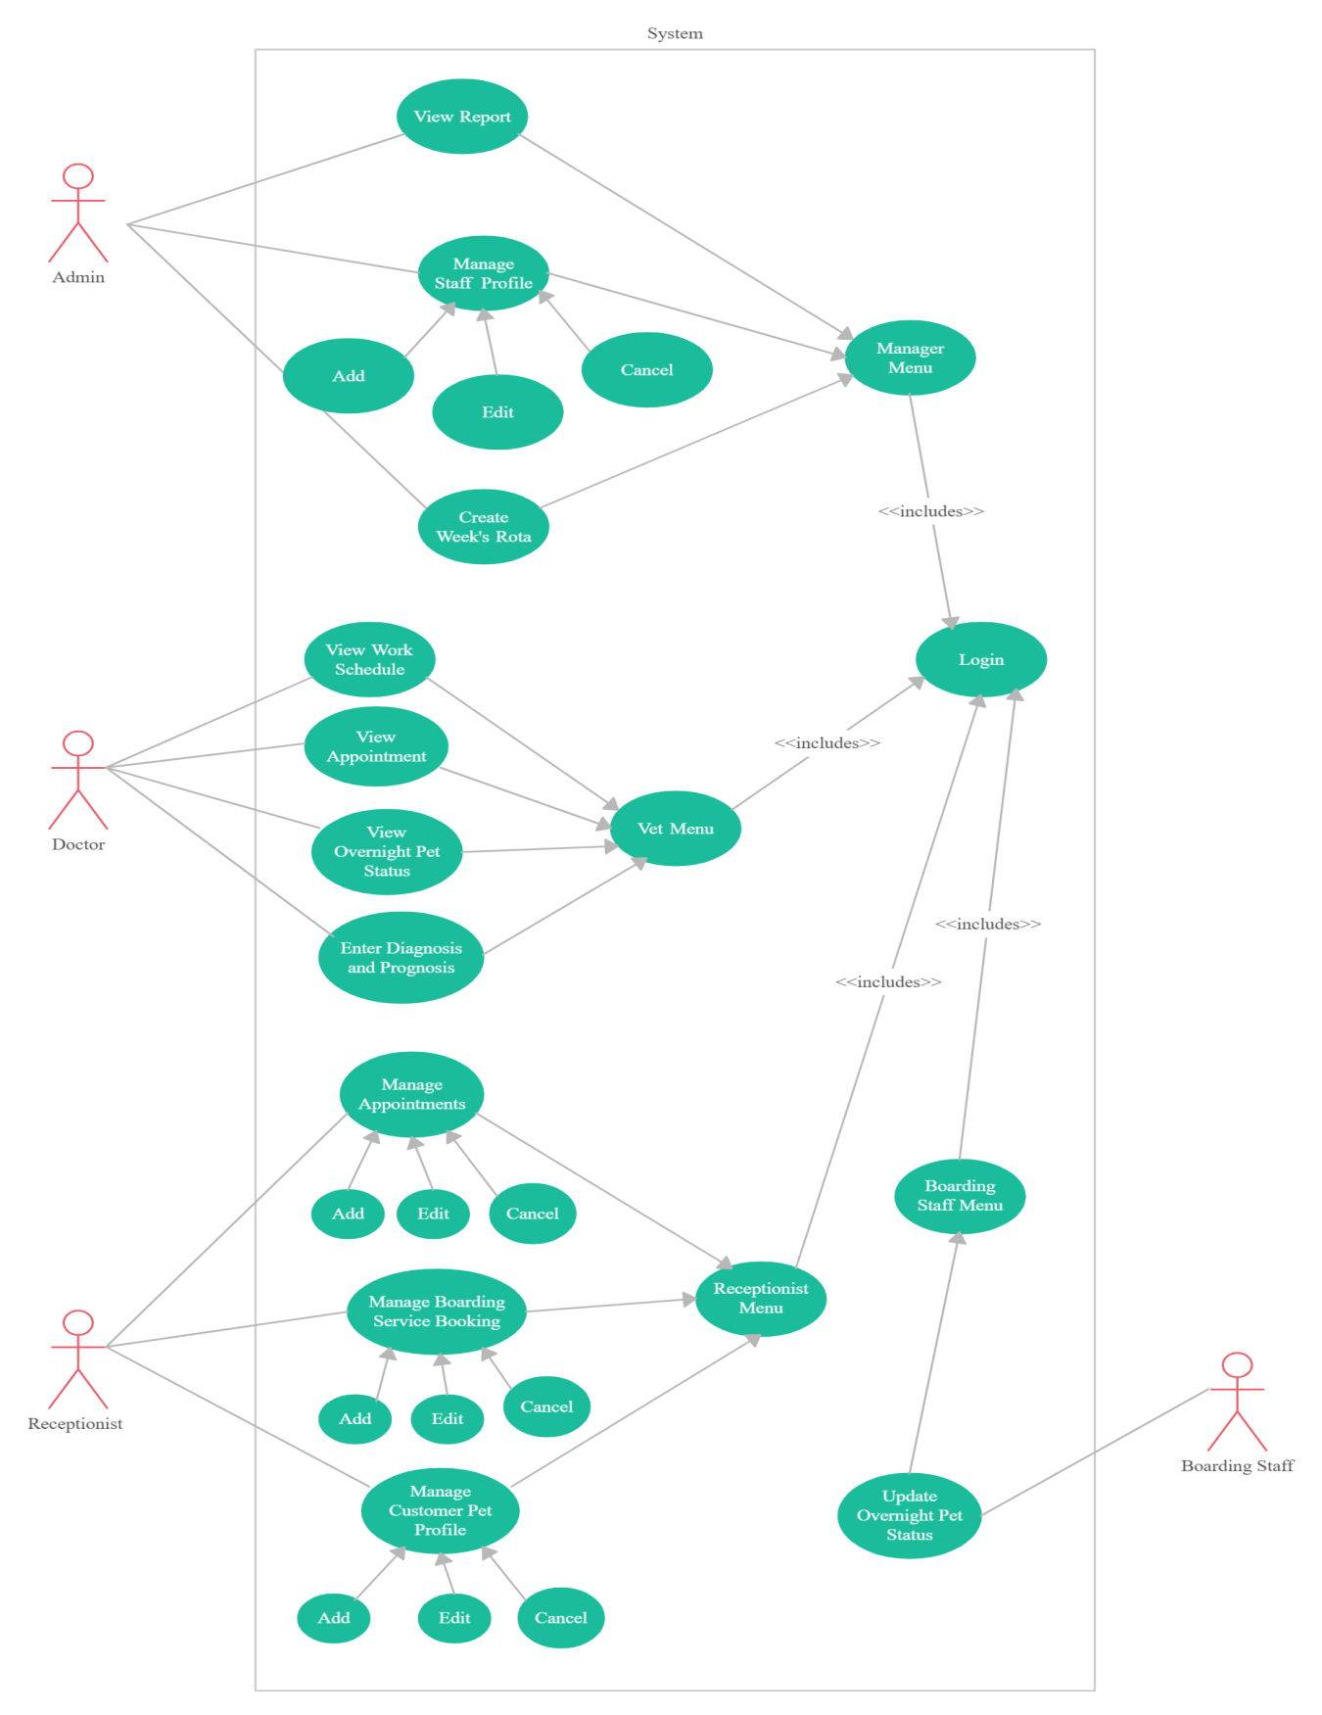

Non-Functional Requirements
Since the system is used in a smart pet clinic, it is a must to ensure that everything is doing well especially performance during the working hours. Few non-functional requirements are found and listed below:

3.5.1 Performance

The system is to be used as a web application and targets users across the globe, so it is expected to be robust i.e. up and running all the time.

3.5.2 Reliability
The system should be reliable all the time. The functions in the system should produce the correct output to the user.

3.5.3 Standard Compliance

The application software must be designed according to the international standards. Moreover, it also focuses on smooth interface design.

3.5.4 Availability
The application software is available 24/7.

3.5.5 Robustness
The application must continue operating despite abnormalities in inputs, filer options etc. Proper error handling must be implemented completely.

3.5.6 Portability
As this software is to work on multiple platforms portability is an essential attribute
And we ensure this by using PHP as our programming language.

Inverse Requirements
- The system should not ask user to confirm email every time he login.
- The System Should not let the user to make changes into the system.
- The System Should not let the user to make changes in profile without login.
- The system should not be too complex.
- The system should not accept any payment service except Credit/Debit card.
- The system should not show a patient to patients which is already reserved by someone.
- When someone clicks on a patient to see features, the system should not allow others to interact with the same patient at the same time.

Design Constraints
- Some of the design and implementation constraints identified are listed below:
- Patients or Admin do not have any rights to edit any data in the system.
- Patient pays the service fees through Debit/Credit to hire the Doctor.
- Online Payment facility may be restricted if the hospital not want this facility for some reasons.
- System is limited to HTTP/HTTPS Protocols.
- Patient cannot use Services with login.

Logical Database Requirements
File Format
The system must store all the user account information as well as the hospital’s records. All the data shall be stored in text-based flat files. For each user account, the login ID, name, password, age, email address (optional) shall be stored in one file. The email address gives the user option to receive any further information or update about the software. Each attribute shall be delimited by a semicolon, and all the entries shall be sorted alphabetically by the login ID.
Accessibility
Only the user who has access to a certain account can access the records belongs to that account. None of the users has access to modify any of the data files.
Security
The Admin can book, add, or remove Doctor only with the permission of admin, as he is the head of the organization. The database first needs his access to allow Admin to make changes into the system.

Other Requirements
Hardware & Software Requirements

Software Requirement
- Visual Studio.Net 2010
- SQL server (Database - Backend)
- Windows XP or above
- Asp.net (Form Design - Frontend)
- Vb.net (coding)
- IIS Server

Hardware Requirements
- Dual Core Processor or above
- 512MB Ram ob above
- 100GB hard disk or above
- Other standard physical devices like, mouse, keyboard etc.

Technical Requirements
Are requirements that outline what is needed to support the project; during development, implementation and ongoing delivery. Include servers to store data and a process for ongoing maintenance related to a website.

Analysis Models
Analysis Model is a technical representation of the system. It acts as a link between system description and design model. In Analysis Modeling, information, behavior, and functions of the system are defined and translated into the architecture, component, and interface level design in the design modeling.

4. Sequence Diagram

4.1 Patient Sequence Diagrams

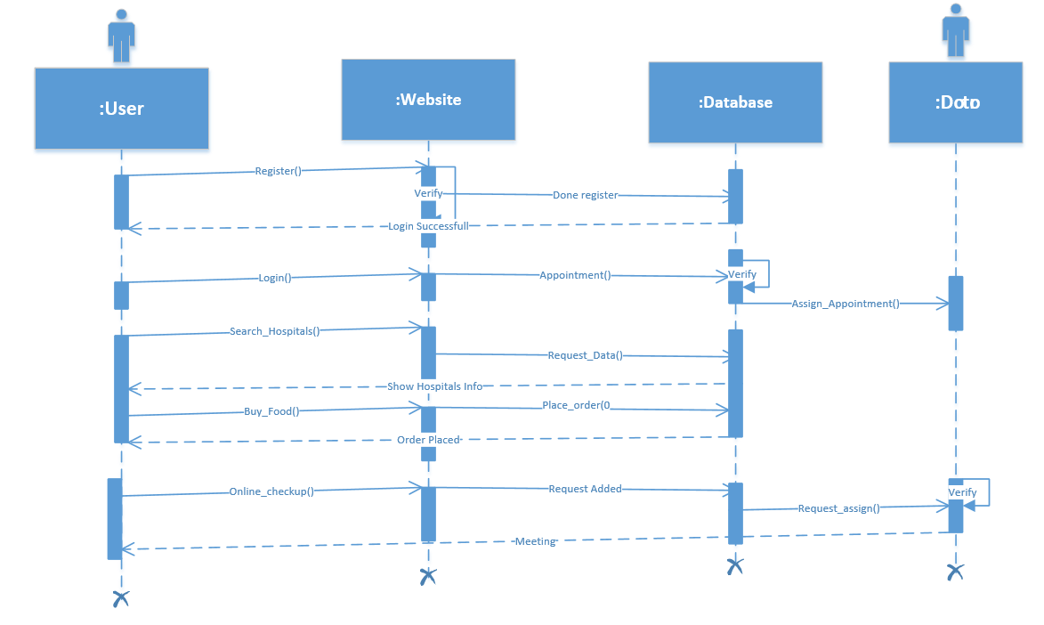

4.2 Doctor Sequence Diagram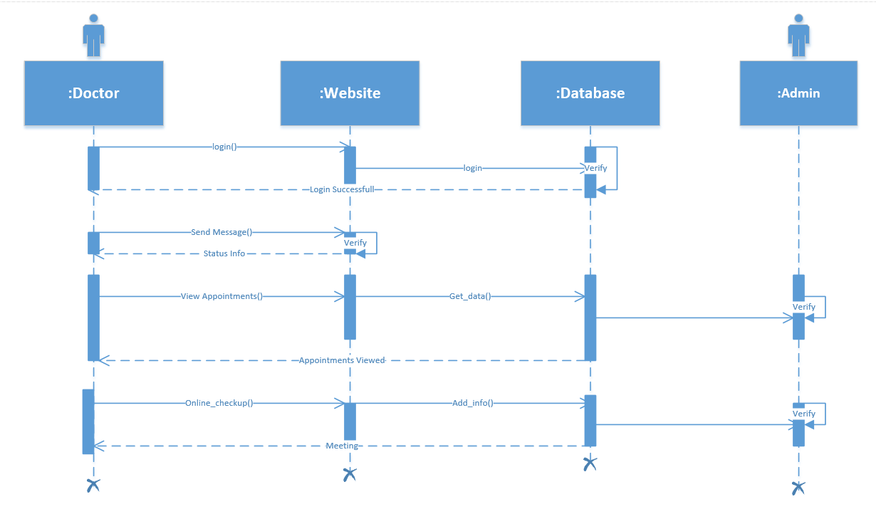
4.3 Admin Sequence Diagram:
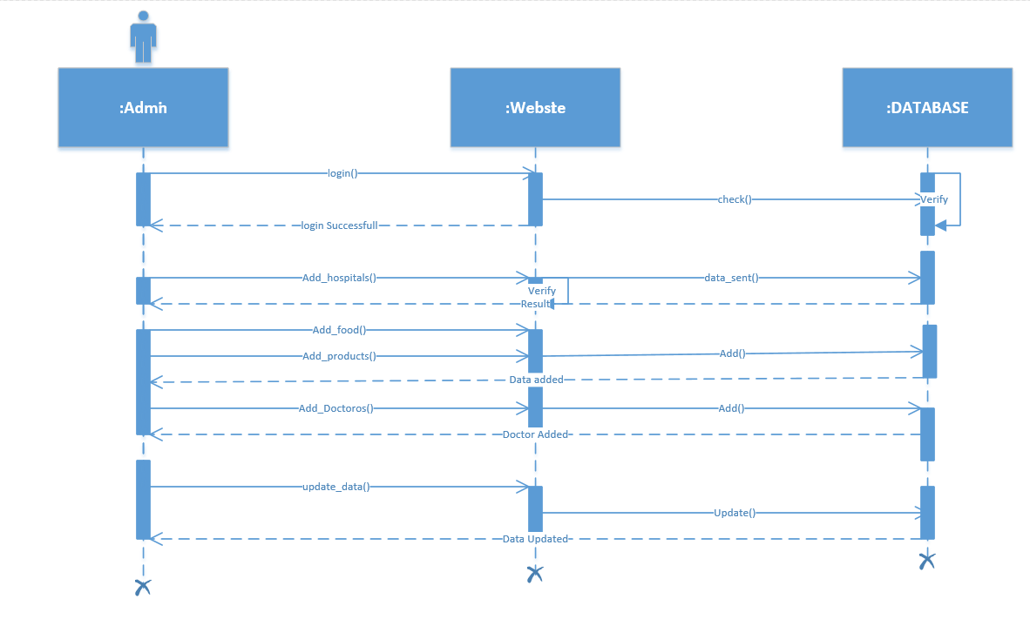

Data Flow Diagrams (DFD)

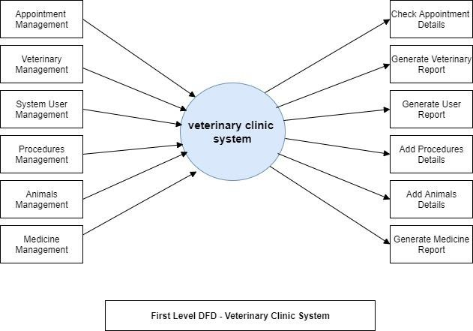

4.4 State Chart Diagrams (SCD)

User

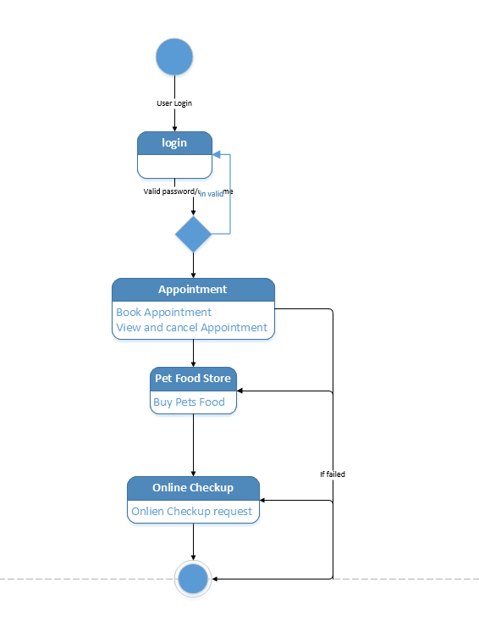

Doctor

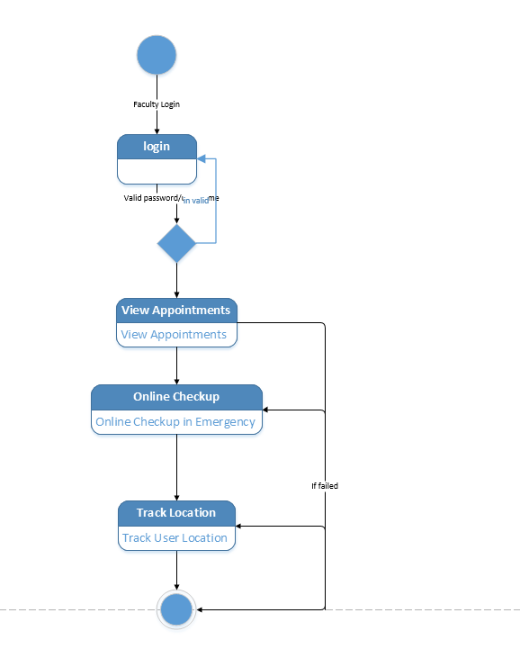

Admin

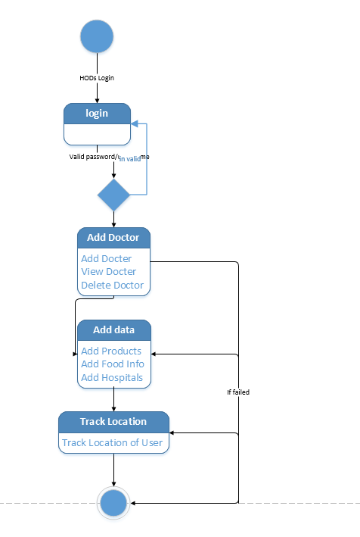

A. Appendices
System Overview
The application is a web-based application which means it only run on web browsers like Google chrome, safari, and opera. The Smart pet Clinic would function in such a way that patient would register with the system, followed by logging in. After registration, the second step is to search for a car using the search box by inputting pick up and drop off date and time. A patient would select the doctor of his/her choice, and then make a appointment.

Organization of the guide
This user guide consists some sections which are; system summary, getting started, and using the system. System Summary section provides a general overview of the system. The summary shows the uses of the system’s hardware and software requirements, system’s configuration, user access levels and system’s behavior. Getting started section explains how to search for the system on the internet and start using it. The section presents briefly system menu.

System Summary
This section shows the general overview of the system. It outlines the uses of the system’s hardware and software requirements, system’s configuration, user access levels and system’s behavior.
2.1 System Configuration
Online Smart pet clinic operates on a web browser installed on any operating system. It is compatible with any version of browser. The system requires internet connection to operate, save data, and load the pages that are contained inside the system.

User Access Levels
A patient must register with the system before he/she appoints a doctor. Contingencies
If there is no internet connection, the system pages will not be loaded and system will not connect to the web server so data will be saved to the database.

Getting Started
Getting started section describes how to get the system on the internet and use it.

System Menu
The Smart pet Clinic uses a dropdown menu which contains the navigation links to the remaining part of the system.

